1. Fixing the bug (answers)

<!DOCTYPE html>

<html lang="en">

<head>

<meta charset="UTF-8">

<meta name="viewport" content="width=device-width, initial-scale=1.0">

<title>Document</title>

</head>

<body>

guvi

<div>

Lorem ipsum dolor sit amet consectetur adipisicing elit.

<div>

<div>

Guvi Geek Network

</div>

</div>

</div>

</body>

</html>

2.

<!DOCTYPE html>

<html lang="en">

<head>

<meta charset="UTF-8">

<meta name="viewport" content="width=device-width, initial-scale=1.0">

<title>Document</title>

</head>

<body>

guvi

<div>

Lorem ipsum dolor sit amet consectetur adipisicing elit.

<div>

<div>

Guvi Geek Network

</div>

</div>

</div>

</body>

</html>

3. Design a contact us form with all fields as required.

<!DOCTYPE html>

<html lang="en">

<head>

<meta charset="UTF-8">

<meta name="viewport" content="width=device-width, initial-scale=1.0">

<title>Contact Us</title>

</head>

<body>

<h1>Contact Us</h1>

<form action="/submit_form" method="post">

<label for="name">Name:</label>

<input type="text" id="name" name="name" required><br><br>

<label for="email">Email:</label>

<input type="email" id="email" name="email" required><br><br>

<label for="phone">Phone:</label>

<input type="tel" id="phone" name="phone" required><br><br>

<label for="subject">Subject:</label>

<input type="text" id="subject" name="subject" required><br><br>

<label for="message">Message:</label>

<textarea id="message" name="message" required></textarea><br><br>

<input type="submit" value="Submit">

</form>

</body>

</html>

OUTPUT:

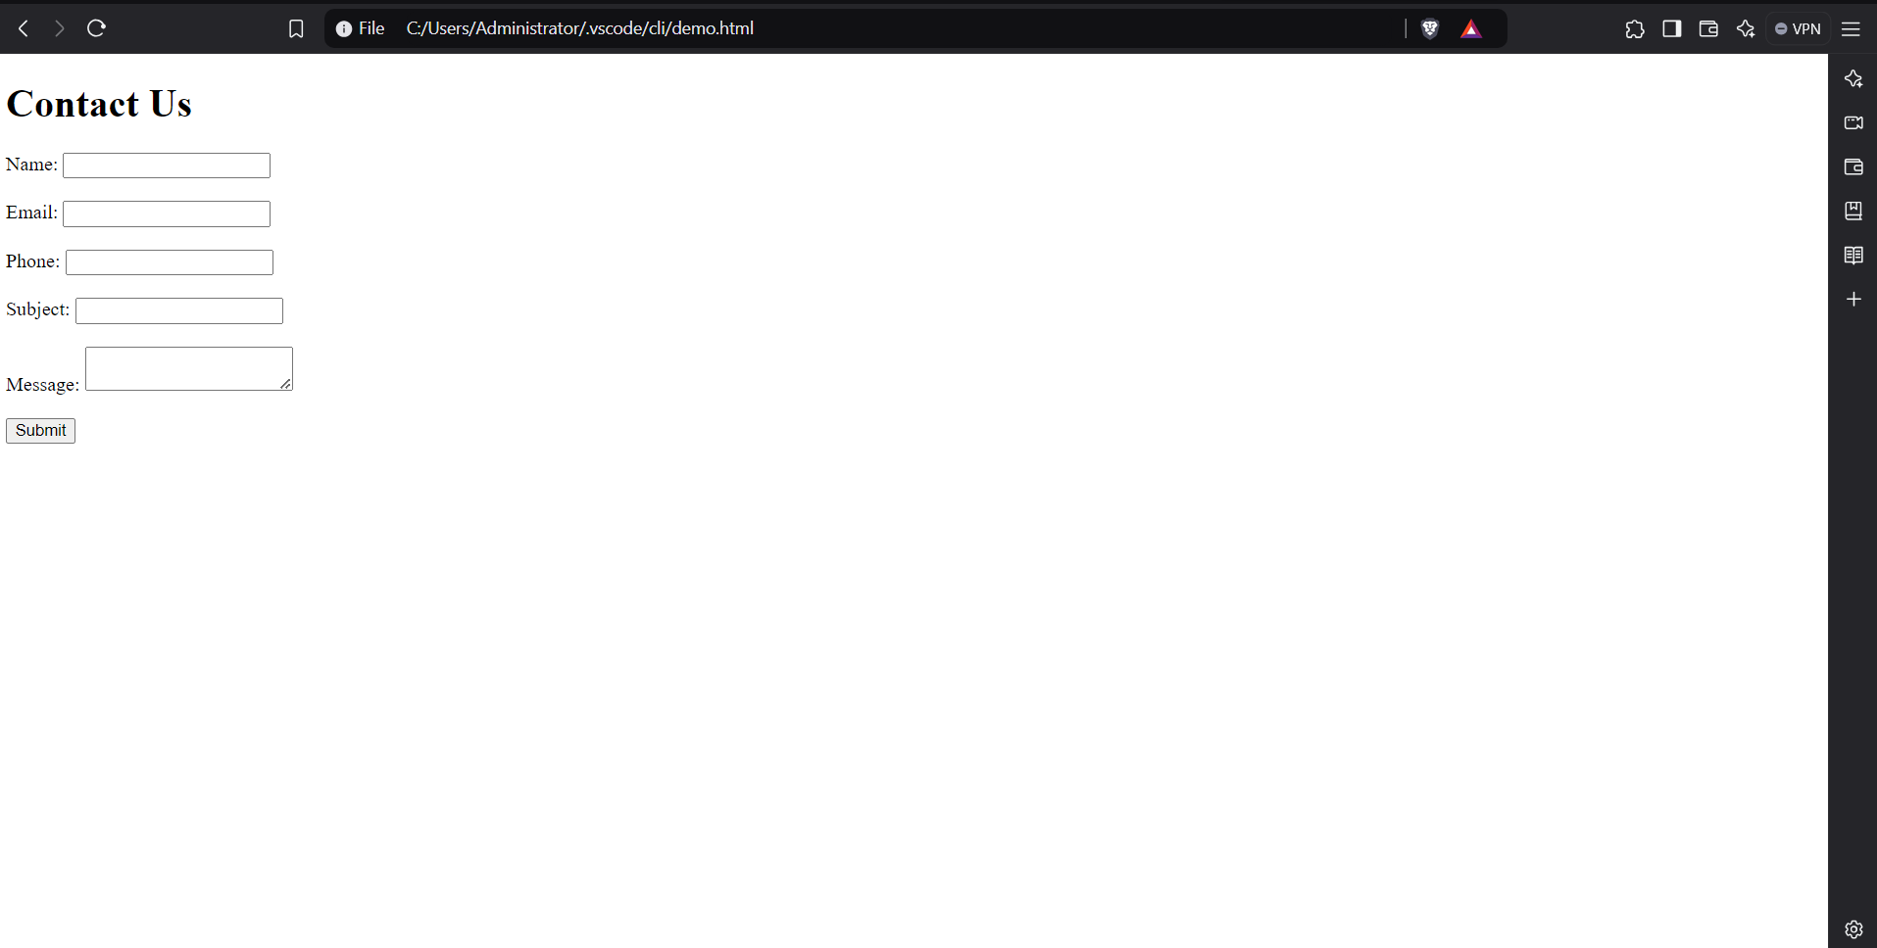

4. Html to print programming language

<!DOCTYPE html>

<html lang="en">

<head>

<meta charset="UTF-8">

<meta name="viewport" content="width=device-width, initial-scale=1.0">

<title>Programming Languages and Databases</title>

</head>

<body>

<h1>Programming Languages and Databases</h1>

<ul>

<li>Programming Language

<ul>

<li>JavaScript

<ol type="a">

<li>Angular</li>

<li>React</li>

<li>Vue.js</li>

</ol>

</li>

<li>Python

<ol type="a">

<li>Django Framework</li>

<li>Flask Framework</li>

</ol>

</li>

<li>Java

<ol type="a">

<li>Spring</li>

<li>Maven</li>

<li>Hibernate</li>

</ol>

</li>

</ul>

</li>

<li>Database

<ul>

<li>MySQL</li>

<li>MongoDB</li>

<li>Cassandra</li>

</ul>

</li>

</ul>

</body>

</html>

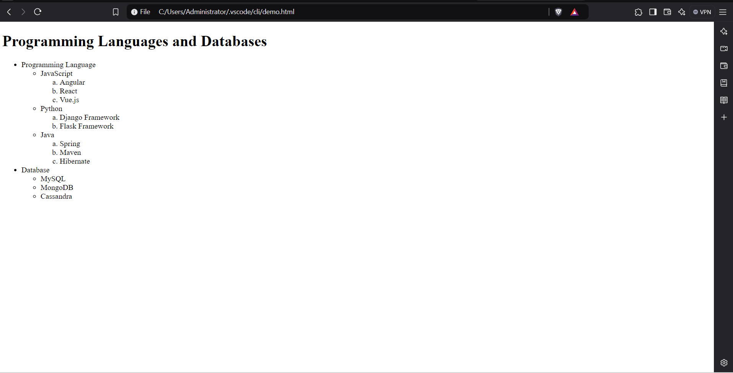

5. Create an element that helps you to open the [https://google.com](https://google.com/) in separate new tab.

<!DOCTYPE html>

<html lang="en">

<head>

<meta charset="UTF-8">

<meta name="viewport" content="width=device-width, initial-scale=1.0">

<title>Open Google</title>

</head>

<body>

<a href="https://google.com" target="_blank">Open Google in a new tab</a>

</body>

</html>

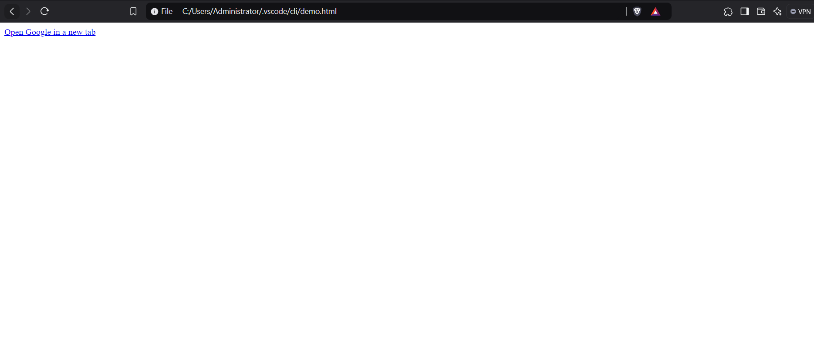

6. In the form, add two radio buttons with grouping them for employee type(Salaried and own business)

<!DOCTYPE html>

<html lang="en">

<head>

<meta charset="UTF-8">

<meta name="viewport" content="width=device-width, initial-scale=1.0">

<title>Contact Us</title>

</head>

<body>

<h1>Contact Us</h1>

<form action="/submit_form" method="post">

<label for="name">Name:</label>

<input type="text" id="name" name="name" required><br><br>

<label for="email">Email:</label>

<input type="email" id="email" name="email" required><br><br>

<label for="phone">Phone:</label>

<input type="tel" id="phone" name="phone" required><br><br>

<label for="subject">Subject:</label>

<input type="text" id="subject" name="subject" required><br><br>

<label for="message">Message:</label>

<textarea id="message" name="message" required></textarea><br><br>

<label for="employee_type">Employee Type:</label><br>

<input type="radio" id="salaried" name="employee_type" value="salaried" required>

<label for="salaried">Salaried</label><br>

<input type="radio" id="own_business" name="employee_type" value="own_business" required>

<label for="own_business">Own Business</label><br><br>

<input type="submit" value="Submit">

</form>

</body>

</html>

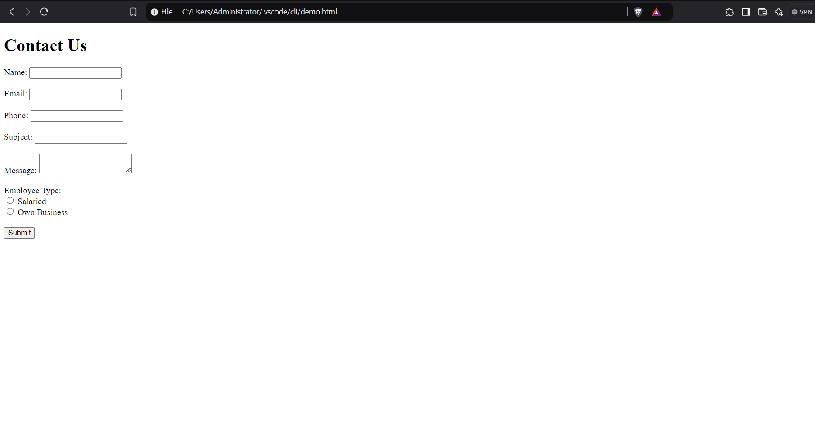

7. Design form shown in the link (<http://evc-cit.info/cit040/formguide/card_0.png>)

8. Use the table tag to design given image [Click here](https://www.bapugraphics.com/assets/img/port_upload_dir/table-4.jpg).

9. Write HTML input tags snippet to show default values for all Form elements.

<!DOCTYPE html>

<html lang="en">

<head>

<meta charset="UTF-8">

<meta name="viewport" content="width=device-width, initial-scale=1.0">

<title>Form with Default Values</title>

</head>

<body>

<h1>Form with Default Values</h1>

<form action="/submit_form" method="post">

<!-- Text input -->

<label for="text">Text:</label>

<input type="text" id="text" name="text" value="Default Text"><br><br>

<!-- Password input -->

<label for="password">Password:</label>

<input type="password" id="password" name="password" value="defaultpass"><br><br>

<!-- Email input -->

<label for="email">Email:</label>

<input type="email" id="email" name="email" value="example@example.com"><br><br>

<!-- Telephone input -->

<label for="phone">Phone:</label>

<input type="tel" id="phone" name="phone" value="123-456-7890"><br><br>

<!-- URL input -->

<label for="url">Website:</label>

<input type="url" id="url" name="url" value="https://www.example.com"><br><br>

<!-- Number input -->

<label for="number">Number:</label>

<input type="number" id="number" name="number" value="10"><br><br>

<!-- Range input -->

<label for="range">Range:</label>

<input type="range" id="range" name="range" value="50" min="0" max="100"><br><br>

<!-- Date input -->

<label for="date">Date:</label>

<input type="date" id="date" name="date" value="2024-12-29"><br><br>

<!-- Month input -->

<label for="month">Month:</label>

<input type="month" id="month" name="month" value="2024-12"><br><br>

<!-- Week input -->

<label for="week">Week:</label>

<input type="week" id="week" name="week" value="2024-W52"><br><br>

<!-- Time input -->

<label for="time">Time:</label>

<input type="time" id="time" name="time" value="12:00"><br><br>

<!-- Datetime-local input -->

<label for="datetime">Datetime:</label>

<input type="datetime-local" id="datetime" name="datetime" value="2024-12-29T12:00"><br><br>

<!-- Color input -->

<label for="color">Color:</label>

<input type="color" id="color" name="color" value="#ff0000"><br><br>

<!-- Checkbox input -->

<label for="checkbox">Checkbox:</label>

<input type="checkbox" id="checkbox" name="checkbox" checked><br><br>

<!-- Radio buttons -->

<label>Radio Buttons:</label><br>

<input type="radio" id="radio1" name="radio" value="1" checked>

<label for="radio1">Option 1</label><br>

<input type="radio" id="radio2" name="radio" value="2">

<label for="radio2">Option 2</label><br><br>

<!-- File input (default file inputs don't have default values) -->

<label for="file">File:</label>

<input type="file" id="file" name="file"><br><br>

<!-- Hidden input -->

<input type="hidden" name="hidden" value="hiddenValue">

<!-- Submit button -->

<input type="submit" value="Submit">

</form>

</body>

</html>

10. In your, HTML page add the below line and Highlight it without using any CSS.

* "HTML & CSS is awesome"

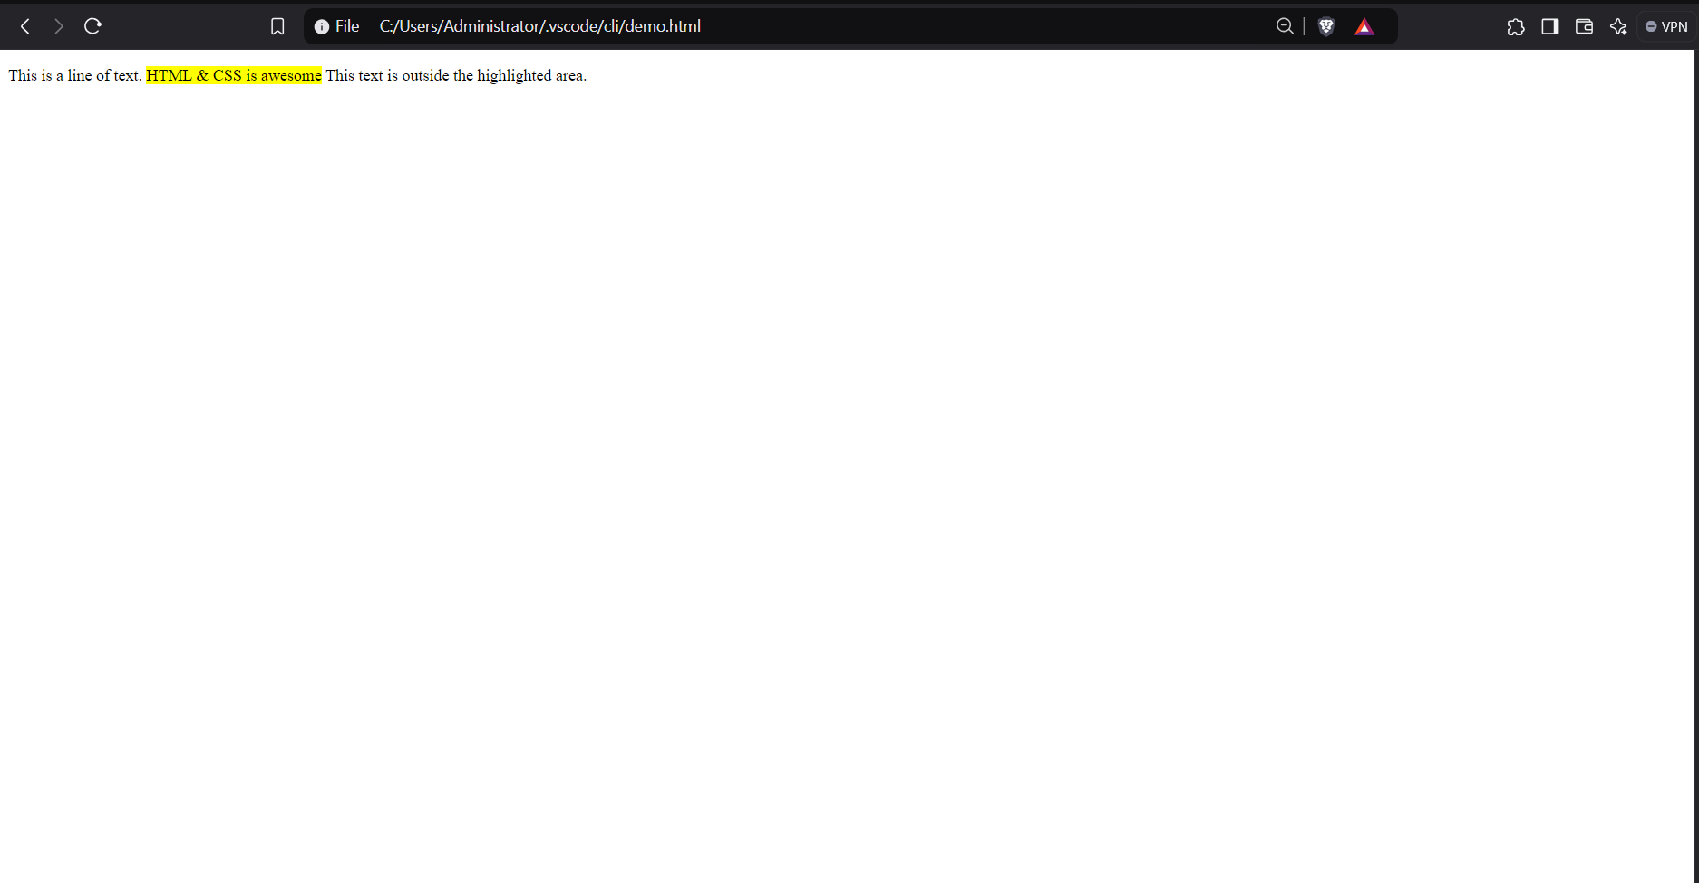

11. Create an HTML page, which should contain all types of input elements.

<!DOCTYPE html>

<html lang="en">

<head>

<meta charset="UTF-8">

<meta name="viewport" content="width=device-width, initial-scale=1.0">

<title>Input Elements</title>

</head>

<body>

<h1>Form with Various Input Elements</h1>

<form action="/submit_form" method="post">

<!-- Text input -->

<label for="text">Text:</label>

<input type="text" id="text" name="text"><br><br>

<!-- Password input -->

<label for="password">Password:</label>

<input type="password" id="password" name="password"><br><br>

<!-- Email input -->

<label for="email">Email:</label>

<input type="email" id="email" name="email"><br><br>

<!-- Telephone input -->

<label for="phone">Phone:</label>

<input type="tel" id="phone" name="phone"><br><br>

<!-- URL input -->

<label for="url">Website:</label>

<input type="url" id="url" name="url"><br><br>

<!-- Number input -->

<label for="number">Number:</label>

<input type="number" id="number" name="number"><br><br>

<!-- Range input -->

<label for="range">Range:</label>

<input type="range" id="range" name="range" min="0" max="100"><br><br>

<!-- Date input -->

<label for="date">Date:</label>

<input type="date" id="date" name="date"><br><br>

<!-- Month input -->

<label for="month">Month:</label>

<input type="month" id="month" name="month"><br><br>

<!-- Week input -->

<label for="week">Week:</label>

<input type="week" id="week" name="week"><br><br>

<!-- Time input -->

<label for="time">Time:</label>

<input type="time" id="time" name="time"><br><br>

<!-- Datetime-local input -->

<label for="datetime">Datetime:</label>

<input type="datetime-local" id="datetime" name="datetime"><br><br>

<!-- Color input -->

<label for="color">Color:</label>

<input type="color" id="color" name="color"><br><br>

<!-- Checkbox input -->

<label for="checkbox">Checkbox:</label>

<input type="checkbox" id="checkbox" name="checkbox"><br><br>

<!-- Radio buttons -->

<label>Radio Buttons:</label><br>

<input type="radio" id="radio1" name="radio" value="1">

<label for="radio1">Option 1</label><br>

<input type="radio" id="radio2" name="radio" value="2">

<label for="radio2">Option 2</label><br><br>

<!-- File input -->

<label for="file">File:</label>

<input type="file" id="file" name="file"><br><br>

<!-- Hidden input -->

<input type="hidden" name="hidden" value="hiddenValue">

<!-- Submit button -->

<input type="submit" value="Submit">

</form>

</body>

</html>

Output:

